**Introduction to MATLAB**

**LAB # 01**

** Fall 2019**

**Fall 2021**

**CSE301L-Signal $ System**

Submitted by: **Ashfaq Ahmad**

Registration No: **19PWCSE1795**

Class Section: **B**

“On my honor, as student of University of Engineering and Technology, I have neither given nor received unauthorized assistance on this academic work.”

Student Signature: ______________

Submitted to:

**Engr Durr-e-Nayab**

April 25, 2021

**Department of Computer Systems Engineering**

**University of Engineering and Technology, Peshawar**

**-------------------------TASK 01--------------------------**

1. Type the sample code in matlab command window:

>> x = 26

>> whos >>

y = int8(x)

>> whos

What difference do you see? State your findings. (Also try uint16, uint32, uint64)

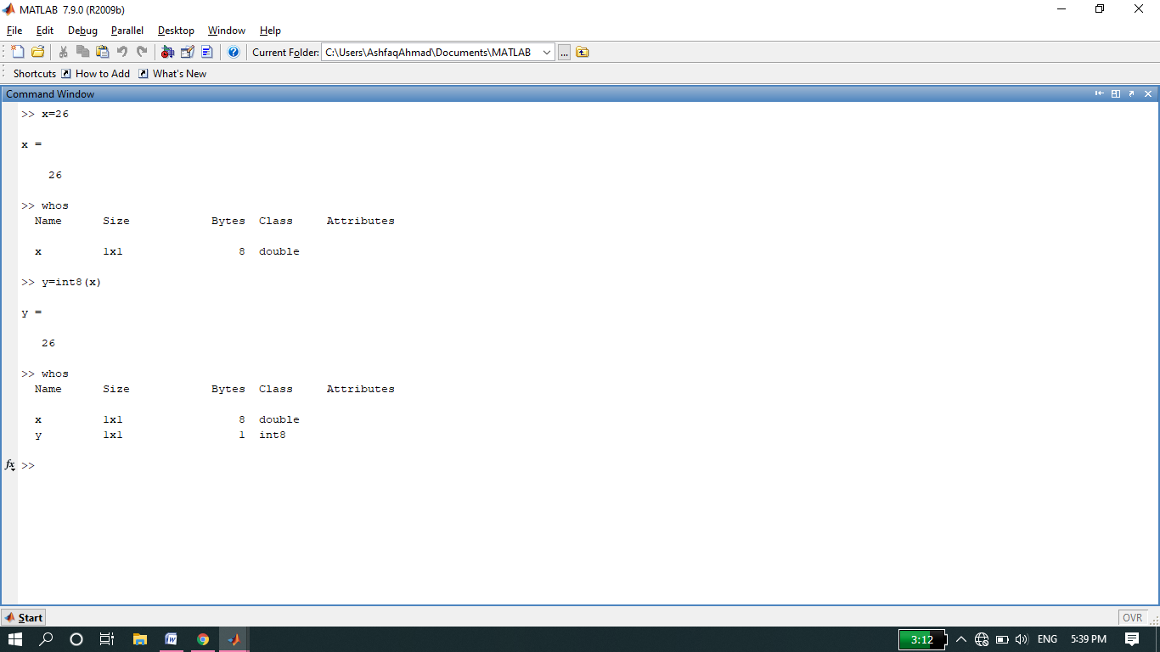   
We see that Mat lab stores numeric data as double‐precision floating point by default. By default the sze of numeric data is 64 bits. We can change the default size of nmeric data by using a conversion function like int8, int16 etc.

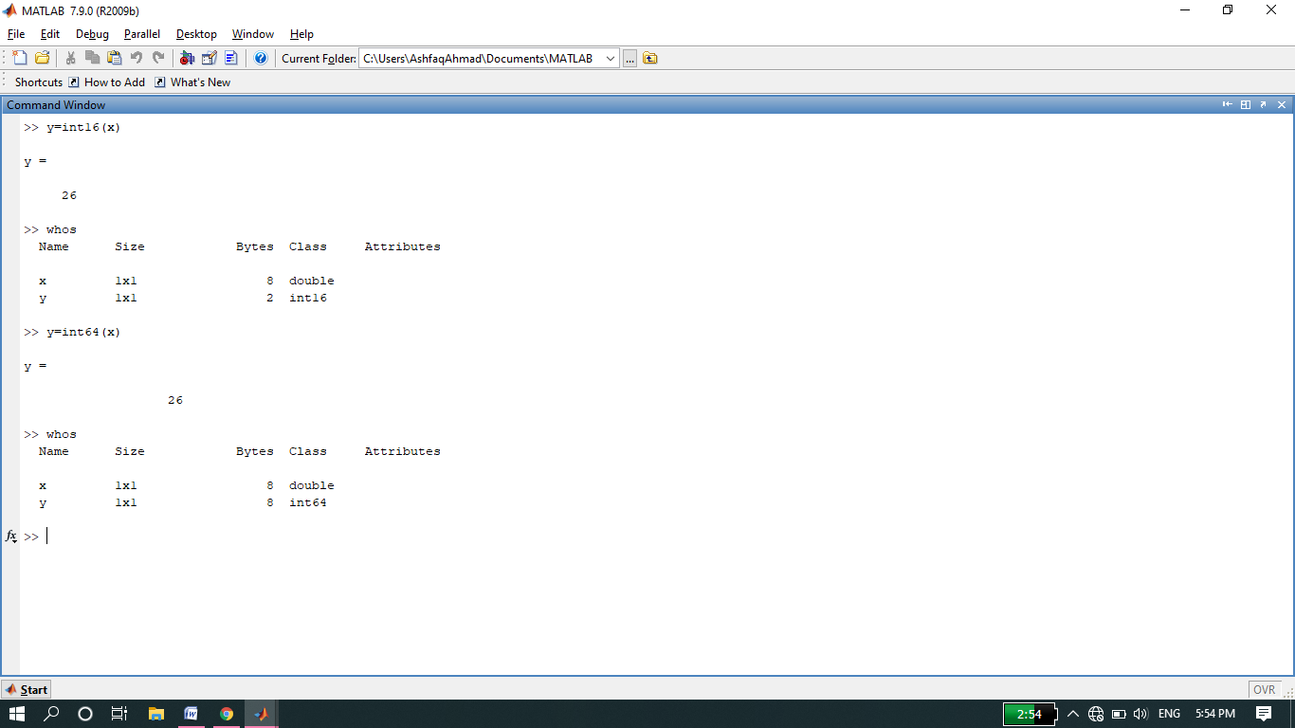

1. Take your name in command window e.g. name = ‘Ali’. Convert it into 8‐bit integer format using int8 function.

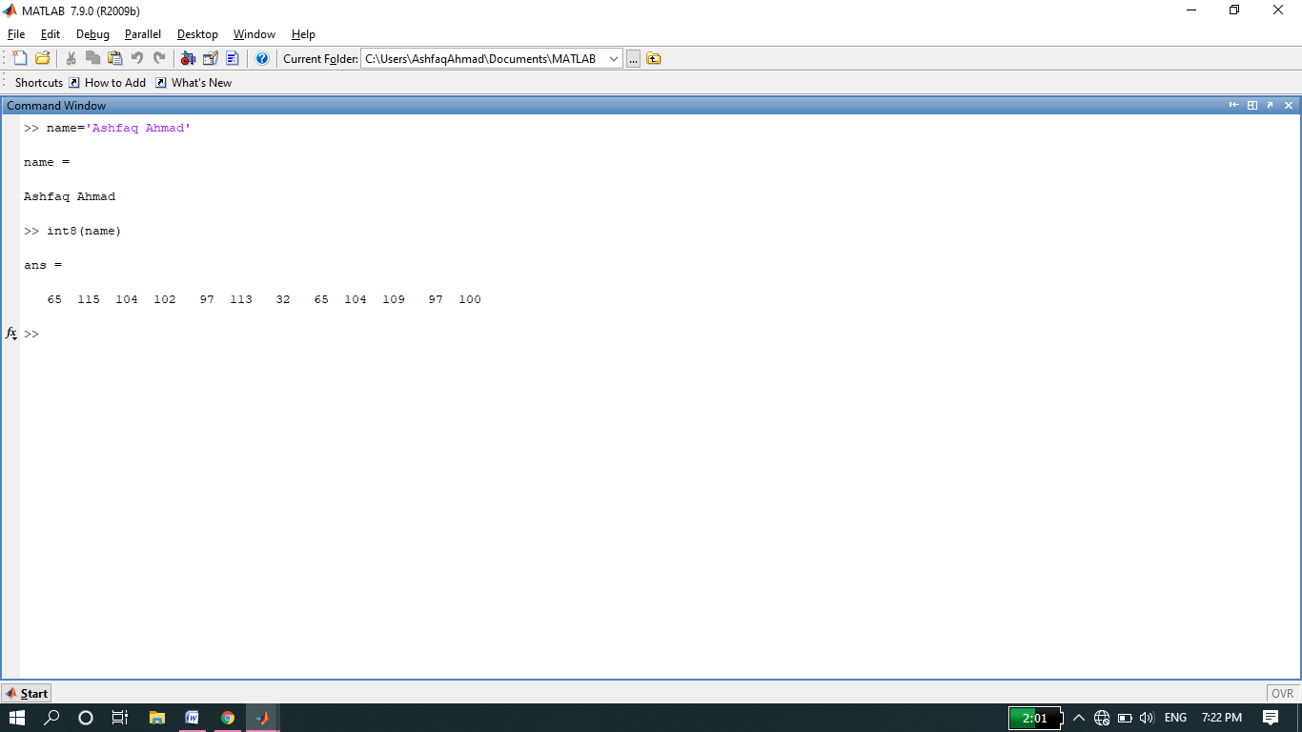

**-------------------------TASK 02--------------------------**

* Create an M-File to prove any five expressions from the following:

Source code:

**clc**

**clear all**

**close all**

**a=input('enter the value of a: ');**

**b=input('enter the value of b: ');**

**disp('******************************');**

**disp('Expression 1')**

**disp('******************************');**

**l.h.s=sin(a+b);**

**r.h.s=sin(a)*cos(b)+cos(a)*sin(b);**

**disp('l.h.s= ');**

**disp(l.h.s);**

**disp('r.h.s= ');**

**disp(r.h.s);**

**disp('******************************');**

**disp('Expression 2')**

**disp('******************************');**

**l.h.s=sin(a)+sin(b);**

**r.h.s=2*sin((a+b)/2)*cos((a-b)/2);**

**disp('l.h.s= ');**

**disp(l.h.s);**

**disp('r.h.s= ');**

**disp(r.h.s);**

**disp('******************************');**

**disp('Expression 3')**

**disp('******************************');**

**l.h.s=sin(a)*sin(b);**

**r.h.s=1/2*[cos(a-b)-cos(a+b)];**

**disp('l.h.s= ');**

**disp(l.h.s);**

**disp('r.h.s= ');**

**disp(r.h.s);**

**disp('******************************');**

**disp('Expression 4')**

**disp('******************************');**

**l.h.s=tan(a-b);**

**r.h.s=[tan(a)-tan(b)]/[1+tan(a)*tan(b)];**

**disp('l.h.s= ');**

**disp(l.h.s);**

**disp('r.h.s= ');**

**disp(r.h.s);**

**disp('******************************');**

**disp('Expression 5')**

**disp('******************************');**

**l.h.s=cos(a)-cos(b);**

**r.h.s=-2*sin((a+b)/2)*sin((a-b)/2);**

**disp('l.h.s= ');**

**disp(l.h.s);**

**disp('r.h.s= ');**

**disp(r.h.s);**

**disp('******************************');**

**OUTPUT:**

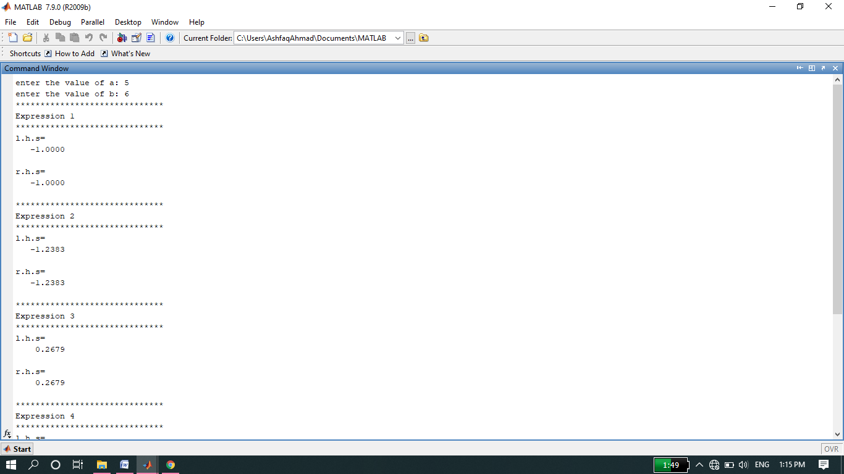

**------------------------- TASK 03 --------------------------**

* Write a CGPA Calculator program using M-File:

**Source code:**

**clc**

**clear all**

**close all**

**result=0;**

**ch=0;**

**a=input('input cs-1 grade points: ');**

**b=input('input credit hours: ');**

**result=result+a*b;**

**ch=ch+b;**

**a=input('input DE grade points: ');**

**b=input('input credit hours: ');**

**result=result+a*b;**

**ch=ch+b;**

**a=input('input CP grade points: ');**

**b=input('input credit hours: ');**

**result=result+a*b;**

**ch=ch+b;**

**a=input('input CPS grade points: ');**

**b=input('input credit hours: ');**

**result=result+a*b;**

**ch=ch+b;**

**a=input('input PS grade points: ');**

**b=input('input credit hours: ');**

**result=result+a*b;**

**ch=ch+b;**

**a=input('input EDG grade points: ');**

**b=input('input credit hours: ');**

**result=result+a*b;**

**ch=ch+b;**

**a=input('input cs-1 lab grade points: ');**

**b=input('input credit hours: ');**

**result=result+a*b;**

**ch=ch+b;**

**a=input('input EDG lab grade points: ');**

**b=input('input credit hours: ');**

**result=result+a*b;**

**ch=ch+b;**

**a=input('input cp lab grade points: ');**

**b=input('input credit hours: ');**

**result=result+a*b;**

**ch=ch+b;**

**c=result/ch;**

**disp('CGPA: ');**

**disp(c);**

OUTPUT:

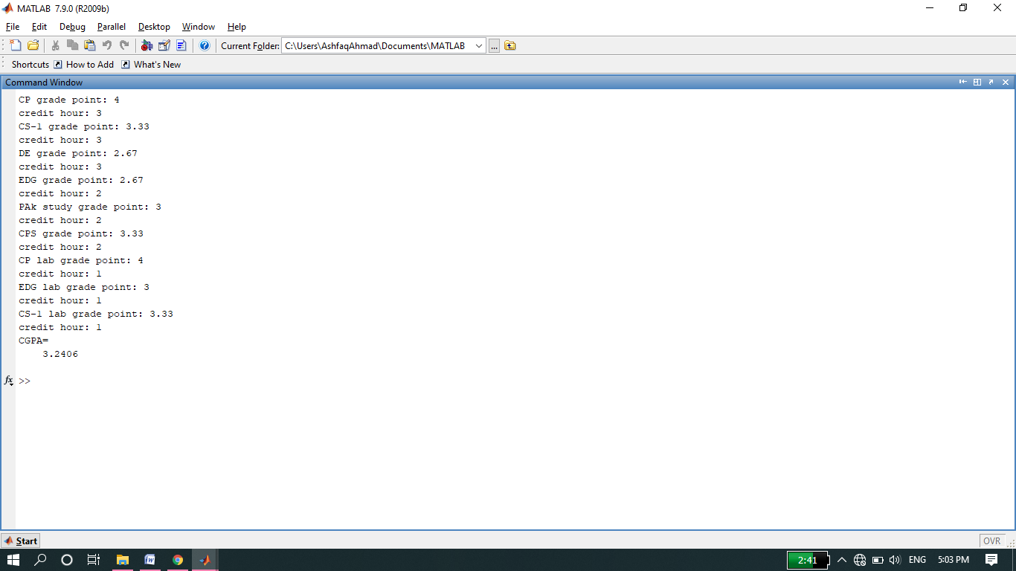

**-------------------------- TASK 04 --------------------------**

* Write a simple code to swap the values of two variables of double type using M-file. Create the logic in such a way that no third variable is used. Show the etime for this code.

Source code:

**clc**

**clear all**

**close all**

**time=clock;**

**v1=input('enter a v1=: ');**

**v2=input('enter a v2=: ');**

**v1=v1+v2;**

**v2=v1-v2;**

**v1=v1-v2;**

**timetaken=etime(clock,time);**

**disp('v1=');**

**disp(v1);**

**disp('v2=');**

**disp(v2);**

**disp('time taken=')**

**disp(timetaken);**

OUTPUT

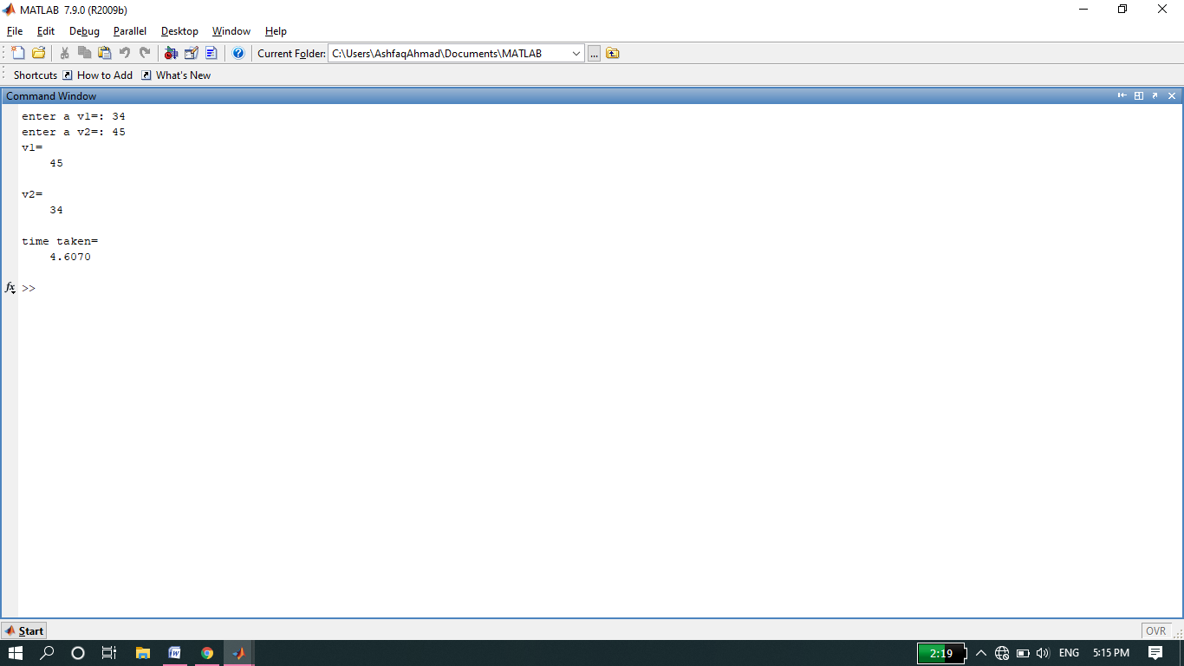

**-------------------------- TASK 05 --------------------------**

* Clock conversion to whole number rather than floating point.

Source code:

clc

clear all

close all

disp(fix(clock));

OUTPUT:

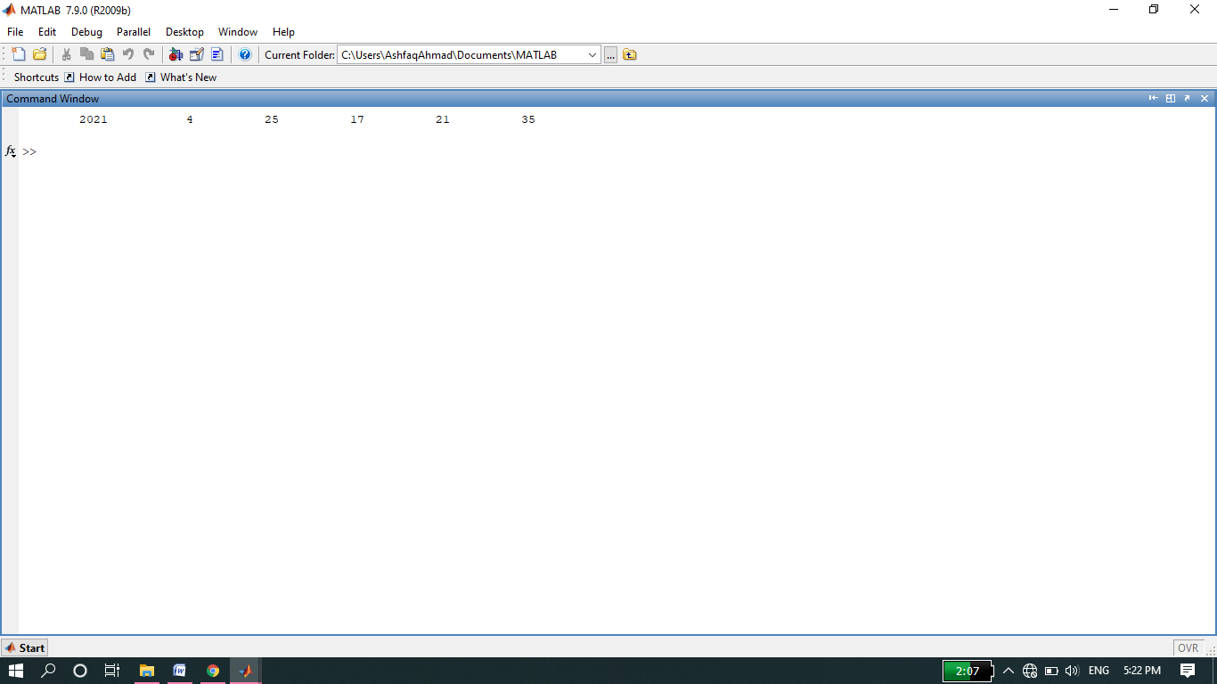

**-------------------------- TASK 06 --------------------------**

* Pethagorous theorem implementation.

**Source code:**

**clc**

**clear all**

**close all**

**a=input('input value of base: ');**

**b=input('input value of perpendicular: ');**

**disp('According to Pethagorous theorem');**

**c=sqrt(a*a+b*b);**

**disp('hypotenuse= ');**

**disp(c);**

OUTPUT:

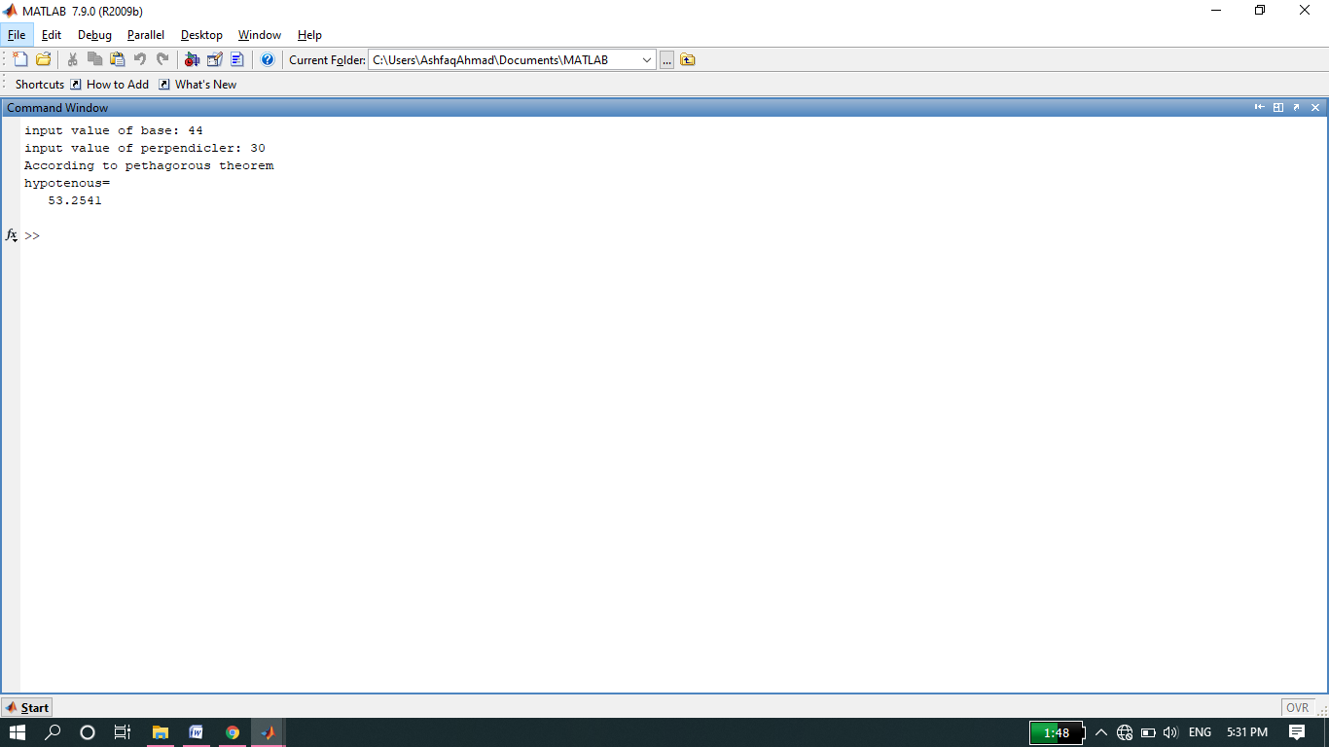

**-------------------------- TASK 07 --------------------------**

* Temperature conversion from Fahrenheit to Centigrade.

**Source code:**

**clc**

**clear all**

**close all**

**a=input('enter temperature in Fahrenheit= ');**

**b=5/9*(a-32);**

**disp('Now temperature in Centigrade= ');**

**disp(b);**

**OUTPUT:**

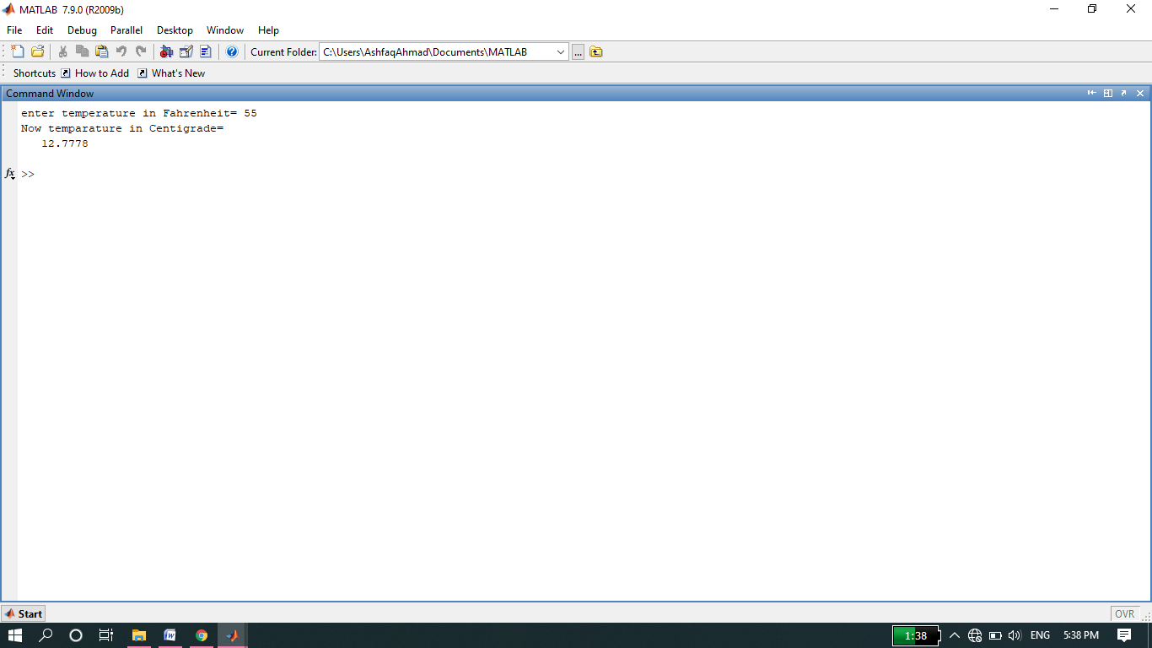

**THE END**